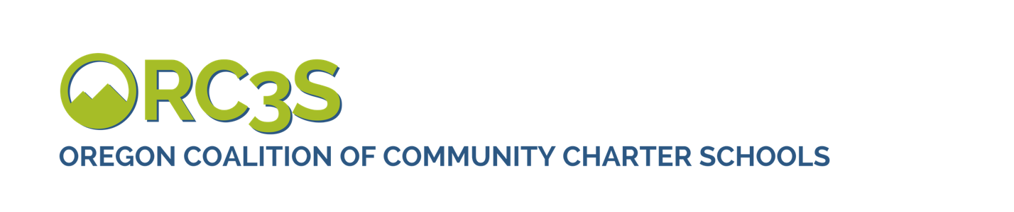

Action Needed, Call Your Legislators: School Improvement Fund Leaves out Charter School Students
The Oregon legislature is hoping to raise $2 billion in new revenue to fund programs and services for our early learning and K-12 students.

Right now, the Joint Committee on Student Success is planning to use the School Improvement Account to channel 50% of those dollars only to district run public schools. This Account does not currently include our public charter schools. That is $1 billion per biennium that would be denied to Oregon’s approximately 40,000 public charter school students. All public school students should be included in the new revenue developed for our public school students.
Below is a sample phone call script that will help you discuss the need for the nearly 40,000 students enrolled in Oregon’s public charter schools to have access to new revenue generated for supporting public education in the state.
SAMPLE EMAIL
SAMPLE EMAIL (personalize this with information about your school):
Dear [Legislator]
As the [FILL IN WHO YOU ARE/WHICH SCHOOL YOU ARE FROM] I want to thank you for working to raise close to $2 billion in new revenue for schools during this legislative session. This investment in public education is critical for the future of our state.
I understand that the Joint Committee on Student Success (JCSS) has been tasked with developing the policy package to improve student success and design the new revenue to fund that package. I also understand that the JCSS is considering the School Improvement Account as the mechanism for flowing new revenue generated for education to local school districts.
The School Improvement Account is established for the purpose of funding grants to be used to increase student achievement and reduce academic disparities for economically disadvantaged students, students from racial or ethnic groups that have historically experienced academic disparities, students with disabilities, and students who are English language learners. The School Improvement Account, does not currently allow public charter schools access to these new funds.
I cannot state this strongly enough: charter school students deserve to be included in the Fund.
- By using the School Improvement Fund as currently written, the Joint Committee on Student Success is considering leaving 40,000 of Oregon’s public charter school students without access to programs and services that would be funded by $1 billion in new education funding.
- The students in my school and all other charter schools are public school students. As a state we cannot continue to treat charter school students as second-class citizens.
- This funding exclusion will further exacerbate inequities between district-run schools and public charter schools. Already K–8th grade charter schools only receive 80% of the State School Fund dollars per pupil allocated to public schools. Right now its budget planning time for our school, and every year I see the gap grow between rising expenses and our reduced revenue per student.
Ultimately, it’s a matter of equity, and it’s Oregon’s children who pay the price. Charter schools can offer an alternative for children who learn in different ways.
As an alternative, Measure 98/High School Success grants provide an example of how state investments can be inclusive of public charter school students. Please ensure that charter school students are included in this investment.
With sincere thanks for your public service and commitment to our children,
YOUR NAME

